- The folder structure changed so you have to set the “src” folder in Eclipse
- Highlight the project and right click to [properties].
- Go to the [Java Build Path] tab and select [add folder].
- Highlight the [camod\software\camod\src] folderfrom the list of source folders and select [ok].
- Highlight the [camod\software\camod\tests] folder and select [ok].
- Select [ok] to exit the main properties window
- Download JUnit4.x.jar from the JUnit website here and add it to classpath. I added it to our lib folder already. Here is the source forge link (9/10/2009):
http://sourceforge.net/projects/junit/files/junit/4.7/junit4.7.zip/download
Eclipse steps:
http://www.vogella.de/articles/Eclipse/article.html#jartoclasspath

- The steps to add this jar into the Eclipse classpath is:

Adding external library (.jar ) to the Java classpath
To add external jars to your project perform the following:
- Create a new folder called lib or use your existing folder
- Select import -> file system -> import the .jar
- Select your project, right mouse click and select properties. Under libraries select "Add JARs" and under “Order and Export" include your jar file and move it up to avoid conflicts.
The following example shows how the result would look like if junit-4.4.jar would be added to a project.
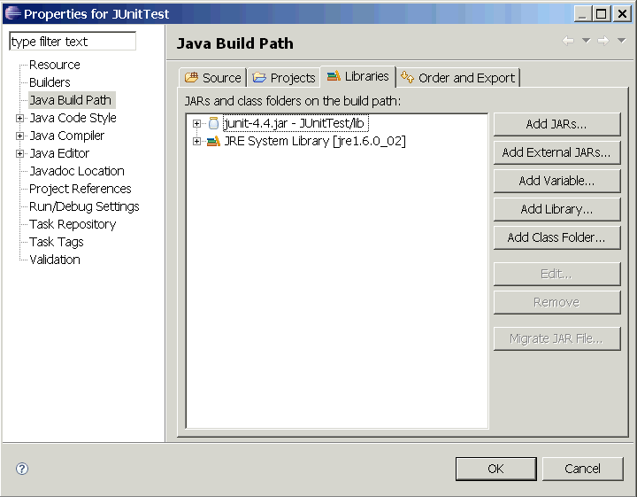

- I fixed many package errors that occurred when we modified directory structure and defined the “test” folder as a source in Eclipse.
For example:
Folder name | Class name | Old import statement | New import statement
Java/web/admin | AdminEditModelsTest | package web.admin; | package unit.java.web.admin;
Java/web/alltests | AllTests | package web.alltests; | package unit.java.web.alltests;
Java/web/allwebtests | AllSearchTests | package web.allwebtests; | package unit.java.web.allwebtests;
 | AllSubmissionTests | package web.allwebtests | package unit.java.web.allwebtests;
Java/web/base | BaseHttpTest | package web.base; | package unit.java.web.base;
 | BaseModelNeededTest | package web.base; | package unit.java.web.base;
Java/web/search | All search tests | package web.search; | package web.search;  Modified reference to TransplantationForm  Modified import location of BaseModelNeededTest and TestUtil
Java/web/submission | All submission tests | package web.submission; | package unit.java.web.submission;  Modified reference to TransplantationForm and all other Transplanation link names  Modified import location of BaseModelNeededTest
Java/web/util | TestUtil.java | package web.util; | package unit.java.web.util;
Java/web | LoginTest.java | package web; | package unit.java.web;
In addition | Modified all import statements to point to new file locations

- We need to add We need to add the NIH certificate to our local Java cacerts file.
- To Locate the localhost.crt and save it under c: in your local computer do the following:
- While running a local JBOSS instance of camod
- In browser goto: http:/localhost/camod (for Firefox) Tools -> Options Click the Advanced tab Click View Certificates
- Find the NIH certificate Export to c:\

- To add this certificate to the java version running locally
- verify which version you are using in Eclipse and modify this version of Java
- open a cmd window
- Navigate to c:\program files\Java_{version}\bin
Note: my JAVA_HOME is pointing to C:\Program Files\Java\jdk1.5.0_10
So I typed “cd C:\Program Files\Java\jdk1.5.0_10” in the command line.
Also go to [Windows][Preferences] look under Java – Installled JREs to verify your version.

- Run the following command

keytool -import -alias camod -keystore ..\jre\lib\security\cacerts -file c:\localhost.crt

keytool -import -alias camod -keystore .\jre\lib\security\cacerts -file c:\localhost.crt

- If it asks for a password the cacerts default password is: changeit

- Answer yes to all the questions, to verify: keytool –list

- Here is the cmd window output:

Microsoft Windows XP [Version 5.1.2600]
(C) Copyright 1985-2001 Microsoft Corp.

C:\>cd C:\Program Files\Java\jdk1.5.0_10

C:\Program Files\Java\jdk1.5.0_10>keytool -import -alias camod -keystore .\jre\lib\security\cacerts -file c:\localhost.crt
Enter keystore password: changeit
Owner: CN=localhost, OU=NCICB, O=NIH, L=Rockville, ST=MD, C=US
Issuer: CN=localhost, OU=NCICB, O=NIH, L=Rockville, ST=MD, C=US
Serial number: 43961066
Valid from: Tue Dec 06 17:27:50 EST 2005 until: Mon Mar 06 17:27:50 EST 2006
Certificate fingerprints:
MD5: 32:C0:58:2B:8E:5B:99:4A:A5:AF:4A:5C:F4:5D:6A:BA
SHA1: 4C:9B:2C:1A:E7:E9:30:A4:A3:59:48:74:C2:7C:58:7D:83:41:0A:33
Trust this certificate? [no]: yes
Certificate was added to keystore
keytool error: java.io.FileNotFoundException: ..\jre\lib\security\cacerts (The s
ystem cannot find the path specified)

C:\Program Files\Java\jdk1.5.0_10>

I've run a few Junit tests successfully but there are many that are broken, asserts are not finding certain words, etc. But it's working and that’s a start!

